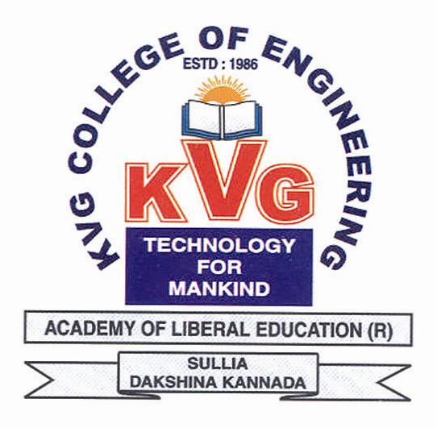
K.V.G. COLLEGE OF ENGINEERING
Kurunjibhag, Sullia, D.K.-574 327, Karnataka, INDIA
E-mail: office@kvgengg.com website: www.kvgengg.com

Department: Central Library

FACULTY PROFILE

Name of the Faculty |  | HARINAKSHI . A |  |  | 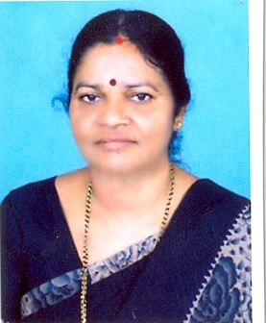
Designation |  | Asst. Librarian
Contact Number
 |  | Mobile: +919449894108
E-mail ID |  | mjharinakshi@gmail.com
- Educational Qualification

Qualification | Specialization |  | Year of Passing | College &Board
Diploma | Library and Information Science |  | 1989 | Women’s Polytechnic, Bondel  MANGALORE  (Department of Karnataka  Technical Education Board  BANGALORE)
B.L.I.Sc | Library and Information Science |  | 2008 | Karnataka State Open University  MYSORE
M.L.I.Sc | Library and Information Science |  | 2011 | Karnataka State Open University  MYSORE
Date of Joining to the College
04-04-1991

- Work Experience
Designation | Experience
Assistant Librarian | 29+Experience

- In-House Experience
 |  |  | From |  |  | To |  | Department
Library Assistant |  |  | 04-04-1991 |  |  | 05-12-2004 |  | Library
Assistant Librarian |  |  | 06-12-2004 |  |  | Till Date |  | Library
- Workshops / Short-termCourse Attended

SL.No. | Workshop Title |  |  |  | Place |  |  |  | Date&Year
 | National Conference on “Information Literacy and Higher Education in Digital Environment” |  |  |  | Karnataka State Open University  MYSORE |  |  |  | March 30,2011
 | Short term course on DCA |  |  |  | Soft Tech Computer Education, SULLIA |  |  |  | Feb 10,2000 to  Sep 21,2000
- Responsibilities Taken in College Level event
Event |  | Positions |  |  |  |  | Duration
 |  |  |  |  |  |  | From |  | From
Ayudha Pooja |  | Rangoli & Decoration Committee |  |  |  |  | 2018 |  | Till the date
Founder’s day celebration |  | Committee Member |  |  |  |  | 28-01-2013 |  | Till Date
- Responsibilities Taken in Department Level
SL.No. | Event |  |  | Role / Responsibilities
 | Library Department |  |  | In charge Lending Section  Lending materials to library Users  Collecting Statistics on Library Use ie. Patron Transactions  Overdue notices Display on the Notice Board  Assist Patrons at the Circulation Desk  Maintains Stacks by re-shelving Materials in Library  Technical Processing Work for New Arrival Books
- Awards / Recognition / Achievements/ Others
- Participated College Throw ball, Tug of war team & other events at Founders day celebration and women’s day Competition and won the prizes.
.
Mrs.HARINAKSHI.A, LIBRARY DEPT., KVGCE, SULLIA, D.K-574327.
Reach me at: mjharinakshi@gmail.com

